Title of template
Skill level needed:
Intermediate/Advanced

Sample designs supported:
1, 2, 3, 4, 5, 6
Designing and Implementing Gridded Population Surveys
gridpopsurvey.com

F3. Data collection – Open Data Kit (ODK)

Last updated: Aug 2022
Set-up and monitor tabular, multimedia, and spatial data collection, then download data

Motivation: This tutorial links to external training material that describes how to program a digital questionnaire in ODK, deploy it to data collectors’ tablets, and monitor submitted questionnaire responses.
ODK can implement common types of survey question:
    - Select a single response from a list
    - Select multiple responses from a list
    - Enter date and/or time
    - Enter a number
    - Enter text
    - Rank items
    - Scan barcodes or QR codes
    - Collect a signature
    - Collect a geocoordinate using Global Positioning System (GPS) satellite signals
    - Take a photo or video or collect an audio recording
Overview: Open Data Kit is a mobile data collection platform that has been used successfully in thousands of projects around the globe. It is the foundation that underlies several paid data collection platforms, including SurveyCTO and Kobo. It is also common for teams to use ODK itself. Tech savvy teams can host their own ODK Central server. Projects with funding can subscribe to ODK Cloud, whereby the professionals from GetODK set up a cloud-based server for you and provide technical support. Pricing varies depending on the level of service you need and the maximum number of form submissions you expect.

Resources:
- Overview: https://docs.getodk.org/getting-started/
- ODK User Forum: https://forum.getodk.org/
- Different workflows https://docs.getodk.org/data-collector-workflows/

Steps:
- Get an ODK Central Server
- Get the ODK Collect App – this application runs on the Android operating system and is compatible with Android tablets and phones. The app is available in the Google Play Store.
- Design your questionnaire form
  - Start with pencil and paper; write down the questions and response options and make note of any skip patterns or questions that need to be repeated (e.g., for a household roster)
  - Implement the questionnaire digitally using Excel or Google sheets, implementing the questionnaire flow using the XLSForm standard described here https://xlsform.org/en/ and here https://docs.getodk.org/xlsform/.
  - You can program constraints to assure that responses fit allowable parameters.
  - ODK has logic for skipping questions depending on the responses to earlier questions.
  - There is an active community on the User’s Forum and they provide helpful answers to clearly expressed questions. There are XLSform training videos available on YouTube, also.

- Upload the questionnaire form to the Central Server. If your questionnaire includes any images or media files, you will upload those to the server, also.

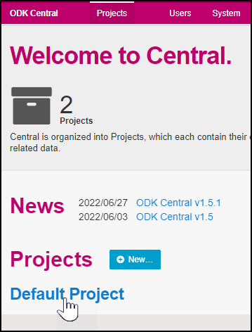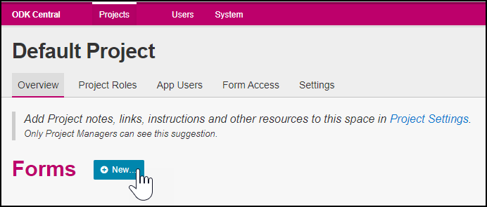

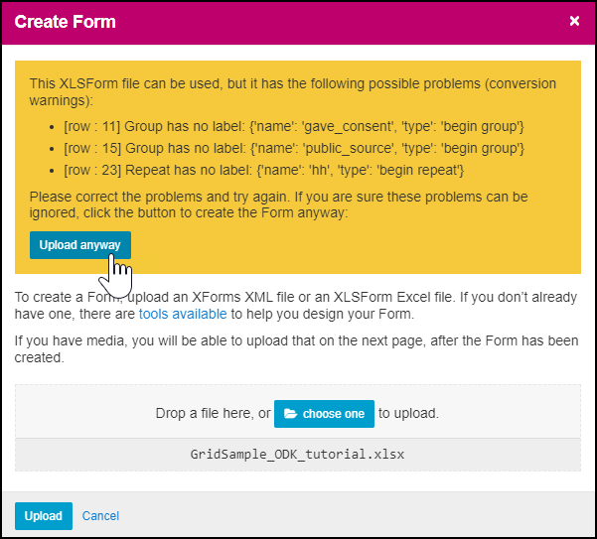
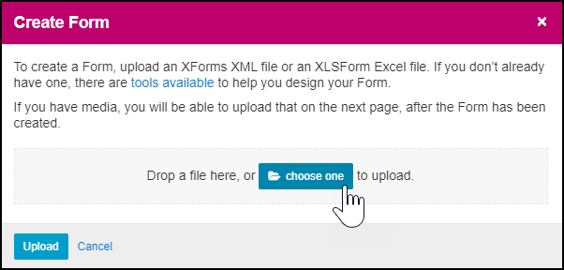

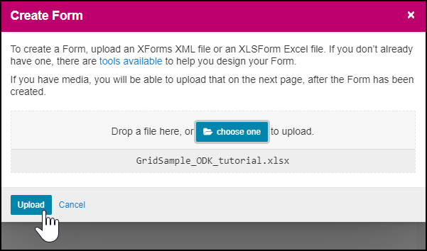
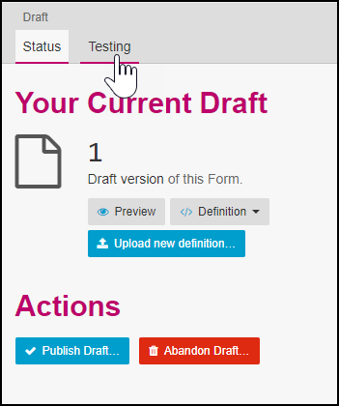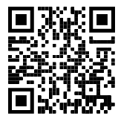
- Circulate the appropriate user QR code to the data collectors that allows them to load the draft form into the Collect app on a mobile device and test it, uploading completed forms to the server. During testing, make a conscious effort to enter responses that trigger or navigate every possible path through the survey and its skip patterns.
- Correct any problems with the XLSform version of the questionnaire, as needed. Reload to Central Server and re-test until you are satisfied that the questionnaire accomplishes what you want it to.
- If the project will use more than one questionnaire, repeat the process above for each questionnaire form.
- Use ODK Central to define access rules to indicate which users can install which forms on their devices.
- Set up the devices using user-role-specific QR codes.
- Train data collectors – ideally the training process involves entering practice data many times to thoroughly understand the various paths through the form.
- View data submissions on the server - monitor uploads during field work, possibly evaluating responses for data quality. Look for forms with surprisingly short or long questionnaire duration. Look for forms with surprising GPS coordinates. Etc.
- Once data collection is complete, set the form stage to ‘Closed’ and download the final dataset.

Sample ODK XLSForm Excel Spreadsheet

This Excel file has three tabs named: Survey, Choices, and Settings.

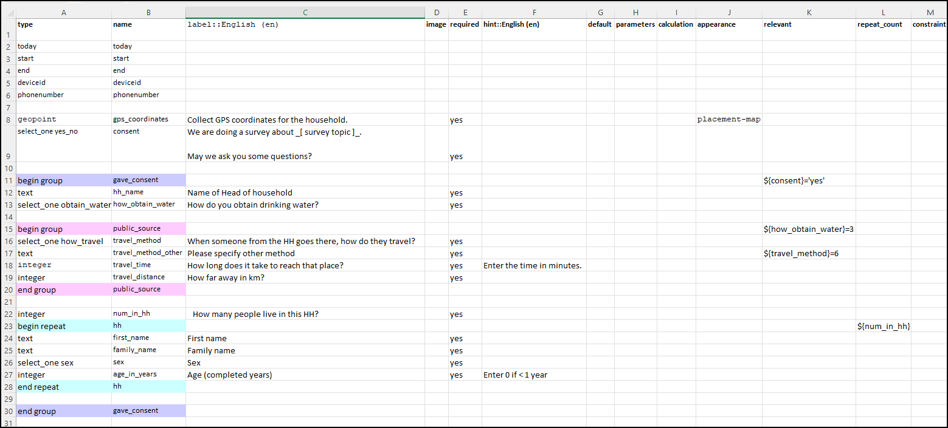
Survey tab of the example questionnaire form

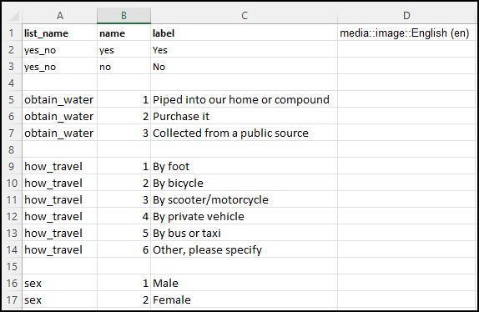
Choices tab

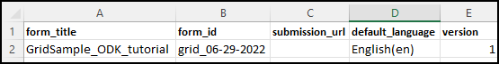
Settings tab

This work © 2022 is licensed under CC BY 4.0

