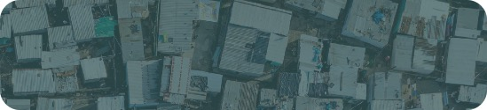
Title of template
Skill level needed:
Basic/Intermediate/Advanced

Sample designs supported:
1, 2, 3, 4, 5, 6
Designing and Implementing Gridded Population Surveys
gridpopsurvey.com

E4. Navigation – Avenza Maps

Last updated: Aug 2022
Navigate offline within PSUs by visualizing the device location over a detailed interactive map

Example: Uganda

Motivation: Regardless of survey design or whether the survey was derived from a gridded population, teams that provide fieldworkers with a device will usually find value in an app that visualizes the device’s location on a detailed, interactive (OSM or imagery) base map while offline. This tool allows the fieldworker to navigate within the PSU, confirm when they have reached the PSU boundary, and/or locate specific assigned locations within the PSU.

Example (Uganda – using GeoPDFs of each PSU): In this example, the team has access to census enumeration area (EA) boundaries from the 2011 Namibia census, and they want to update EAs with population estimates from the 2020 WorldPop-Constrained gridded population estimates.

Resources:
- Avenza YouTube channel: www.youtube.com/channel/UCeZXZIkHlWtW73pfj6Vdr1A
- Avenza Maps Basic Training: www.youtube.com/watch?v=z3sj5AYC3EI

Steps:
- Download Avenza Maps in the Google Play Store or App Store.
- Create a new Avenza Maps account, if you do not have one already.
- Allow Avenza Maps to use your device’s location (for offline navigation) and to access media files (to upload your own GeoPDFs).

- When the device is connected to Wi-Fi or data, GeoPDFs can be uploaded from cloud storage locations (e.g., Dropbox, Google Drive), URL, or QR code. Here, we demonstrate upload of GeoPDFs from Dropbox.
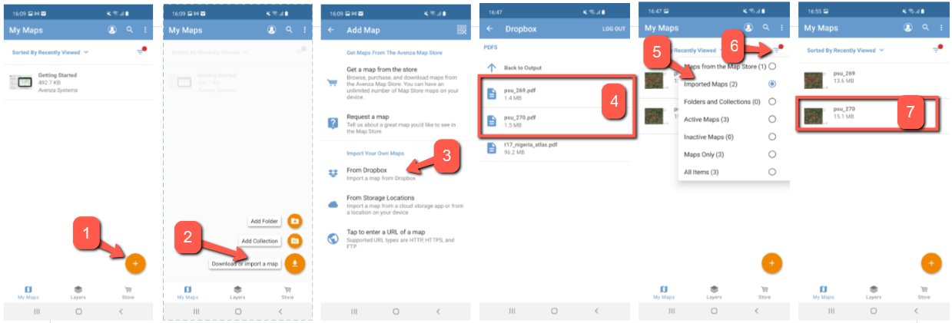
- Locate and select all of the GeoPDFs that you wish to upload to the device. Once uploaded, these files will appear in My Maps as Imported Maps.

- To start navigation, select a map and click the crosshair button. The device location will appear as a blue dot on the map with a blue halo showing the location error. If the device has a compass, the map will spin depending on your direction of travel.
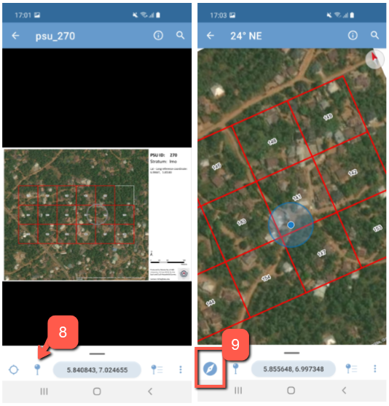

This work © 2022 is licensed under CC BY 4.0

