Title of template
Skill level needed:
Basic/Intermediate/Advanced

Sample designs supported:
1, 2, 3, 4, 5, 6
Designing and Implementing Gridded Population Surveys
gridpopsurvey.com

E3. Navigation – SW Maps

Last updated: Aug 2022
Navigate offline within PSUs by visualizing the device location over a detailed interactive map

Example: Nepal

Motivation: Regardless of survey design or whether the survey was derived from a gridded population, teams that provide fieldworkers with a device will usually find value in an app that visualizes the device’s location on a detailed, interactive (OSM or imagery) base map while offline. This tool allows the fieldworker to navigate within the PSU, confirm when they have reached the PSU boundary, and/or locate specific assigned locations within the PSU.
At the time of writing, SW Maps was only available for Android devices.
Example (Nepal – using a KML file of all PSUs):
In this example, the team has access to a KML file of all PSU boundaries from GridSample.

Steps:
- In the Google Play Store, download SW Maps . The first time that you use SW Maps, allow the app to access your media files and device location.
PSU boundary files can also be upload as a geoJSON, geopackage, or shapefile.
- Save the PSU KML boundary file to the SW Maps kml folder on the device.
- In Android 10, the KML file can be moved on the device from a messaging app (i.e., WhatsApp) to the SW Maps folder.
(Device) From: Internal storage > WhatsApp > Media > WhatsApp Documents > community.kmz
(Device) To: Internal storage > SW_Maps > Maps > kml
SW Maps is suitable for teams with no GIS skills but requires some manual setup of base map imagery on each device before fieldwork. Thus, this tool is better suited to surveys with fewer PSUs, and/or smaller PSUs.
- In Android 11, the SW Maps folder on the device is only visible when connected to a computer via USB cable.
(Computer) From: MyPC > MyPhone > Phone > Android > media > com.whatsapp > WhatsApp > Media > WhatsApp Documents
(Computer) To: MyPC > MyPhone > Phone > Android > media > np.com.softwel.swmaps > Maps > kml
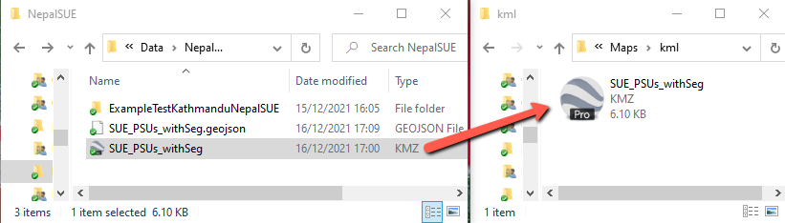
- In the SWMap app, display the KML file by:
  - Selecting the layers button.
  - Adding a layer.
  - Choosing KML layer folder.
  - Giving the layer a short, recognizable name, and adding it to SW Maps.
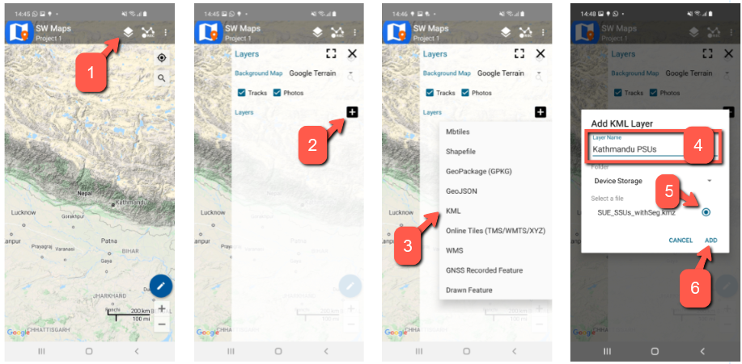
- Change the base map from Google Terrain to Google Satellite (or other preferred base map).

Alternatively, GIS teams might upload GeoTIFF files of your own very high-resolution imagery.
To minimize time and effort spent by the survey management team, include device set-up in fieldworker training so that fieldworkers gain familiarity with SW Maps at the same time they set-up their own devices.
- When the device is connected to Wi-Fi or data, cache (i.e., ensure the device “remembers”) all imagery tiles in a given PSU by zooming in all the way, then moving the screen around the entire PSU at full zoom. Caching PSU imagery while online enables offline navigation on the device later.
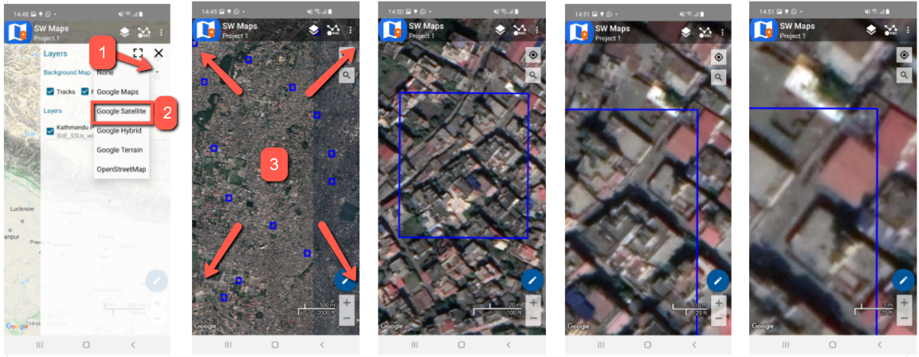
- Start navigation while connected to Wi-Fi or mobile data, with My Location turned on and Power Saving Mode turned off in settings. Then select the crosshair button. This shows your location on the map with a red halo representing potential error in location. The crosshair feature will continue to work when the Wi-Fi or mobile data settings are turned off now.
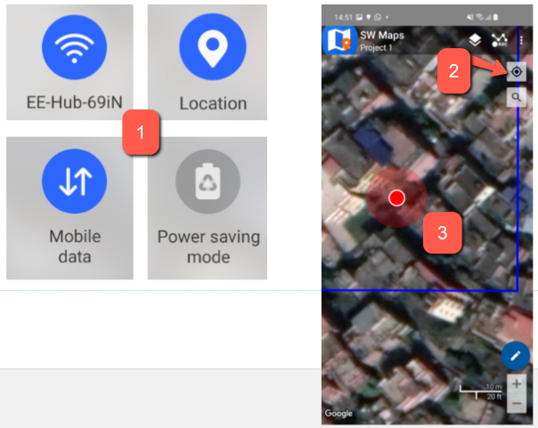
This work © 2022 is licensed under CC BY 4.0

