Title of template
Skill level needed:
Basic/Intermediate/Advanced

Sample designs supported:
1, 2, 3, 4, 5, 6
Designing and Implementing Gridded Population Surveys
gridpopsurvey.com

E2. Navigation – Google Maps

Last updated: Aug 2022
Navigate to a PSU using Google Maps

Example: Namibia

Motivation: Use this tutorial to navigate longer distances (e.g., between PSUs) while offline.

Example: In this example, the team has a latitude/longitude point within the PSU that they wish to navigate to (e.g., generated in tutorials A1, A3, or A6).

Steps:
- While you are connected to Wi-Fi or data, download and install the Google Maps app to your mobile device.
- Enter a latitude/longitude point location within the PSU that you wish to navigate to, select directions, and choose your start location.
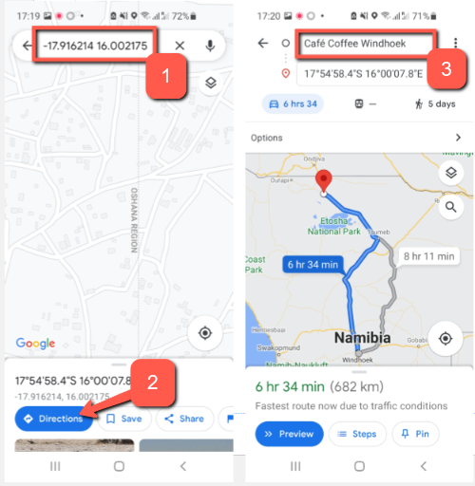

- Select “options” and download offline directions.
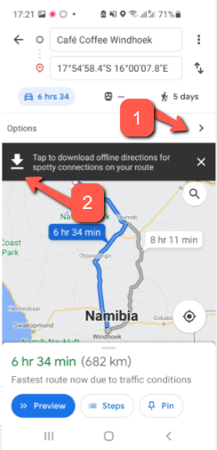

This work © 2022 is licensed under CC BY 4.0

