Title of template
Skill level needed:
Basic/Intermediate/Advanced

Sample designs supported:
1, 2, 3, 4, 5, 6
Designing and Implementing Gridded Population Surveys
gridpopsurvey.com

E1. Navigation – MAPS.ME

  - Last updated: Aug 2022
Navigate to a PSU using MAPS.ME

Example: Namibia

Motivation: Use this tutorial to navigate longer distances (e.g., between PSUs) while offline. MAPS.ME stores a road network map from OpenStreetMap to your mobile device, and thus is limited by device storage capacity, and might not include secondary and tertiary roads.

Example: In this example, the team has a latitude/longitude point within the PSU that they wish to navigate to (e.g., generated in tutorials A1, A3, or A6).

Steps:
- While you are connected to Wi-Fi or data, download and install the MAPS.ME app to your mobile device.
- Within the MAPS.ME app, download OpenStreetMap road map(s) covering your survey area.
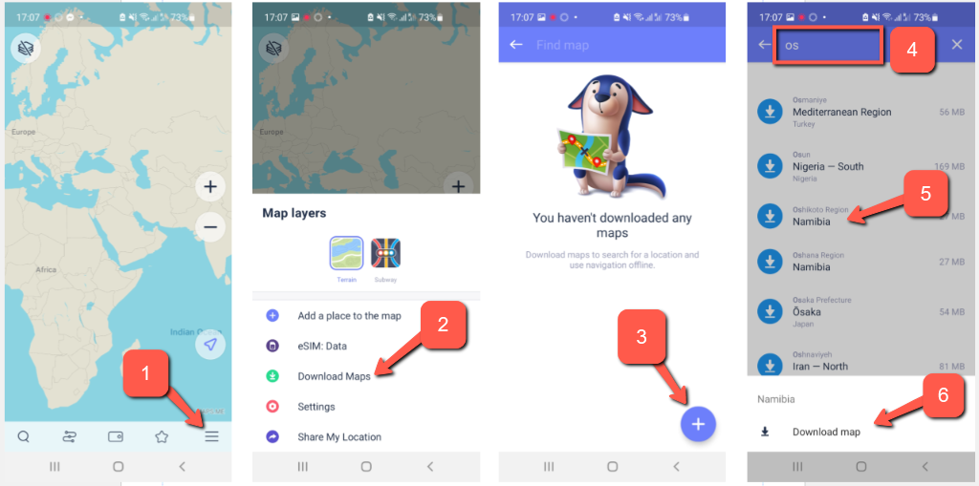

- Enter a latitude/longitude point location within the PSU that you wish to navigate to, choose your start location, and press the “start” button to begin offline navigation.
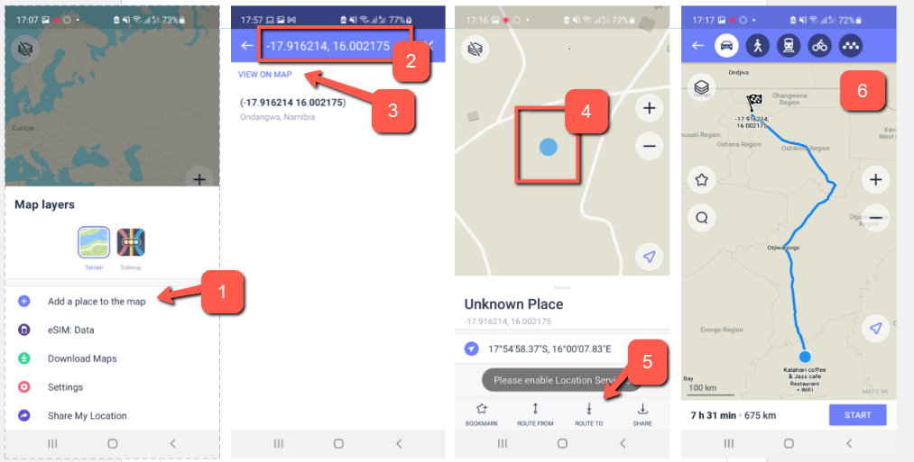

This work © 2022 is licensed under CC BY 4.0

