Title of template
Skill level needed:
Basic/Intermediate/Advanced

Sample designs supported:
1, 2, 3, 4, 5, 6
Designing and Implementing Gridded Population Surveys
gridpopsurvey.com

D3. Map production – Google Earth maps

Last updated: Aug 2022
Prepare simple imagery-based field maps in Google Earth

Example: Nepal

Motivation: Use this tutorial to manually generate A3 or A4 paper field maps with imagery base maps for each PSU. A benefit of Google Earth is that imagery tends to be very high resolution and fairly current, and no special GIS skills are required. However, a limitation of this tool is that each PSU map must be generated manually; there is no batch processing capability. Users with GIS skills might use Tutorial D4 instead to batch produce PSU maps with satellite imagery base maps.

Example: In this example, we generate A3 PDFs of PSUs in Kathmandu Valley, Nepal to be printed as paper field maps. Paper field maps provide field staff with an additional navigation tool and can be used to track buildings visited.
Google Earth maps can only be generated manually one at a time, which makes this tool less attractive for teams with GIS skills, though some teams with GIS skills may still choose to use this tutorial if the Google Earth imagery is more up to date than other imagery available. The use of imagery as a base map layer is helpful in rural settings and small cities (where OpenStreetMap data tends to be incomplete), and in dynamic or very high-density urban settings (where visual clues in the imagery such as roof color is helpful for navigation).

Steps:
- Ensure that Google Earth Pro is downloaded and installed. www.google.com/intl/en-GB/earth/
- Select File > Open to import your PSU boundaries file (e.g., KML, GeoJSON, Shapefile).
- Double click on the first PSU ID in the Places window to zoom in to a PSU. If needed, zoom in further, and select View > Reset > Tilt & Compass to center the screen over the PSU.

- Create a map layout for the first PSU by selecting File > Print or the Print button. This opens the print menu bar. After specifying a layout for the first PSU, print (save) it to PDF, and then zoom to each of the other PSUs one by one and print additional PSU maps to PDF. For example:
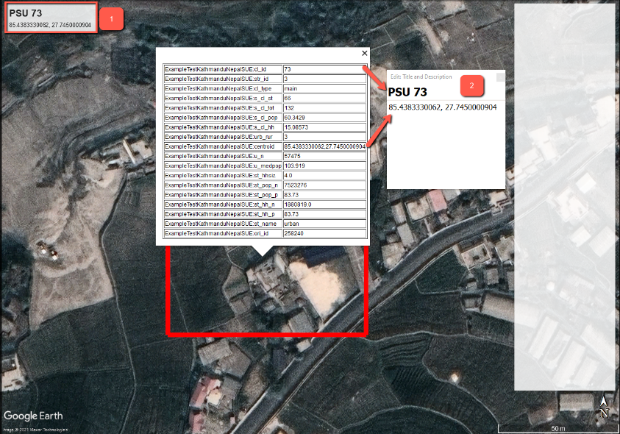

  - Double-click the Title and Description box, and change the Title to the PSU ID and the Description to the PSU centroid latitude/longitude coordinate.
  - Under Map Options, turn off Legend and add HTML Area field. Double-click the HTML box to edit/remove the text. We formatted it here as a large white area for note-taking by field staff.
  - Right-click the folder that contains the PSU polygons in the Places window, and select Properties > Style, Color to change the style of all polygons. Here we specify a 25-width red outline.
  - Under Print, select a PDF program as the printer.
  - Under Page Setup, select A3 as the paper size, and ensure that the print quality is set to high.

  - Finally, select the Save PDF button to print (save) the PSU map as a PDF. The final product is shown below.
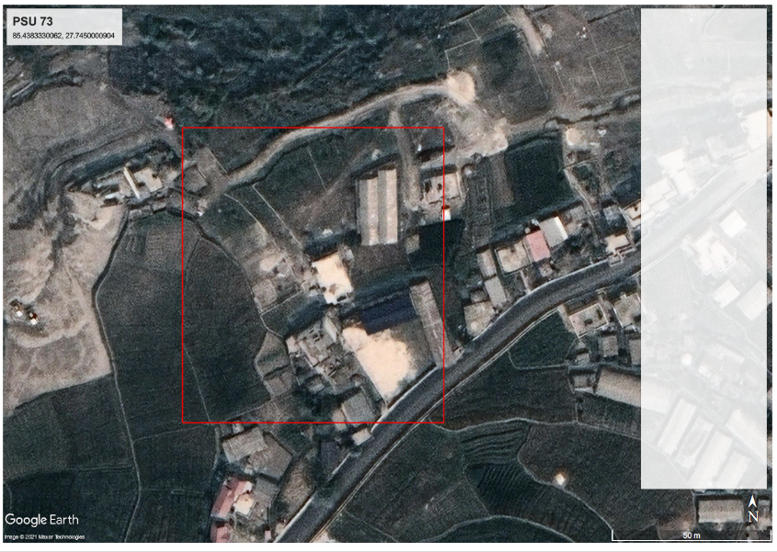

- Zoom to the next PSU by double-clicking the PSU ID in the Places window, then:
  - Zoom in (to the same zoom level as the first map such that the scale bar is identical).
  - Adjust the Tilt & Compass.
  - Manually update the Title and Description.
  - Select the Save PDF button to save the map to PDF.
  - Repeat this step for each PSU.
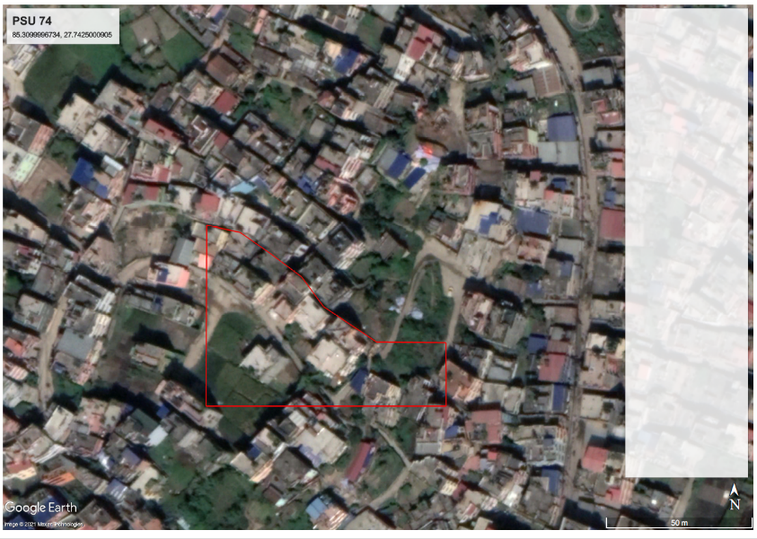
This work © 2022 is licensed under CC BY 4.0

