Title of template
Skill level needed:
Basic/Intermediate/Advanced

Sample designs supported:
1, 2
Designing and Implementing Gridded Population Surveys
gridpopsurvey.com

D2. Map production – OpenStreetMap (OSM)

Last updated: Aug 2022
Update paper maps and edit roads and buildings in OpenStreetMap (OSM)

Example: Nepal

Motivation: Use this tutorial to update building footprints, roads, and pathways in OpenStreetMap (OSM). This tutorial can be used in support of any sample design but is most useful if your team is performing a two-stage sample with a separate listing of households before interviews (e.g., Designs 1 or 2). Specifically, update OSM within PSUs based satellite imagery (preloaded in the tool) before producing field maps for the listing team, and then make any minor edits to OSM buildings, roads, and paths after the listing to improve the accuracy of maps produced for interview teams. This tutorial is particularly helpful in high-density, complex, urban settings.

Resources:
- OpenStreetMap tool: www.openstreetmap.org
- Learn OSM step-by-step guide: https://learnosm.org/en/

Example: In this example, we have produced paper field maps of PSU boundaries over OSM in Kathmandu Valley, Nepal using a free, open tool called Map Campaigner (see Tutorial D1). The idea is to mark up the paper base map based on field observations, then make these changes to OSM using a free satellite image as a reference point in OSM. These instructions can therefore be used with any paper field maps that display PSU boundaries over an OSM base map, including maps produced in a GIS (e.g.,
Tutorial D4).

Steps during fieldwork:
- Before fieldwork, instruct listers to use a clear, simple protocol to update building footprints, roads, and pathways using a pen or pencil on their paper maps. For example, the Surveys for Urban Equity (SUE) project used the following convention to markup paper maps:
  - Mark new/edited permanent building footprints and their number of levels. Permanent buildings have brick or concrete walls.
  - Mark the approximate boundary of a “group” of shacks or tents, and the number of shacks or tents. Shacks or tents are buildings without brick or concrete walls.
  - Mark new/edited streets (on which a car can pass) with a solid line.
  - Mark new/edited paths (on which a car cannot pass) with a dotted line.
  - Mark sections of a street or path to delete with an “X”.
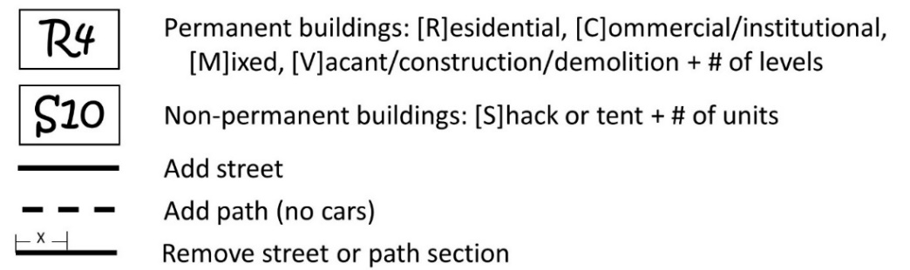
See the SUE planning team guide for more information: https://medicinehealth.leeds.ac.uk/downloads/download/95/planning_team_guide.
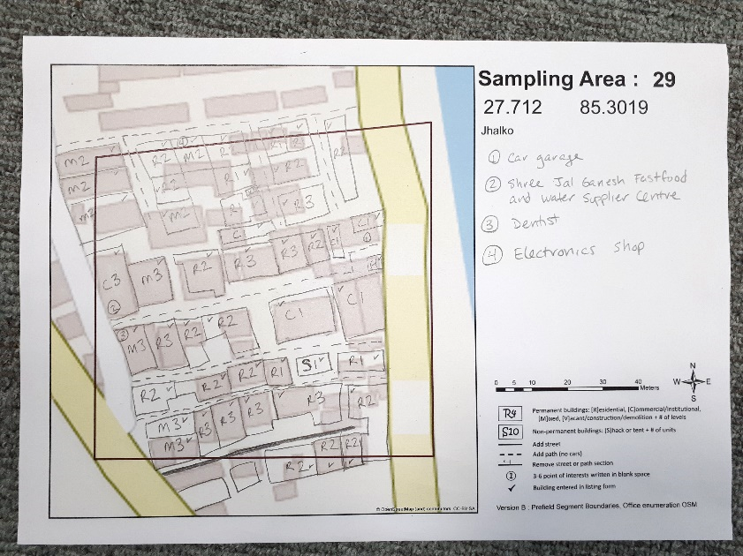

Steps in OpenStreetMap:
- Sign up for an OSM account, if you do have not one already. www.openstreetmap.org/user/new
- Log into www.openstreetmap.org.
- Select Edit to begin OSM editing mode.
- Follow prompts to “Start the Walkthrough” or select the help button to link to the interactive Walkthrough tutorial which will prepare you to add and edit features in OSM.
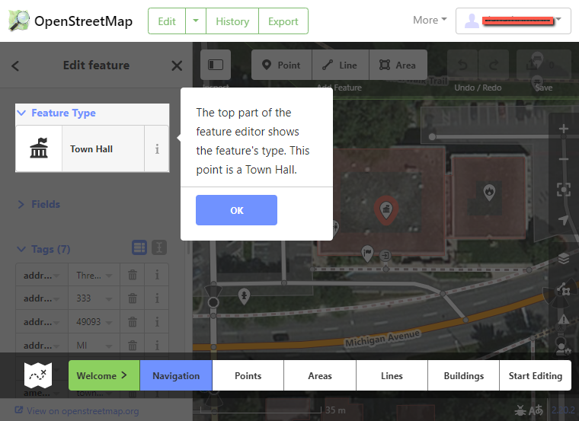

This work © 2022 is licensed under CC BY 4.0

